Giving Campaign Social Media Calendar and Text.
Giving Post #1 – Send out Tuesday, Nov. 28 | Content
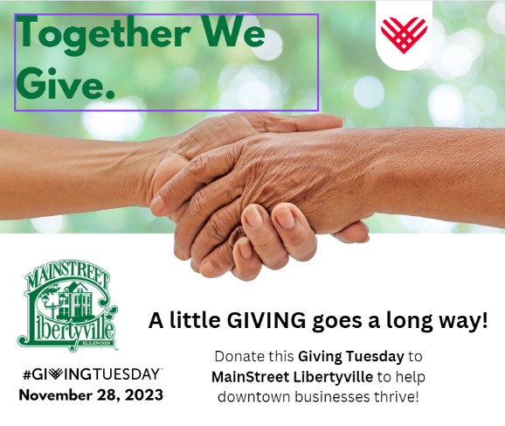 | MainStreet Libertyville is participating in Giving Tuesday, on this Tuesday, November 28, and we’d love your support.  Giving Tuesday is a powerful National Day of Giving, raising funds and generating awareness after Black Friday and Cyber Monday. This global philanthropic movement helps non-profit organizations by encouraging people and organizations to work generously together to transform communities and their world.  To become a member of MainStreet Libertyville and to participate in Giving Tuesday, you may donate to MainStreet Libertyville. Your donations will allow MainStreet Libertyville to support our local businesses and make downtown Libertyville a place for families and friends to gather.  #GivingTuesday #MainStreetLibertyville #SmallBusinesses  (Please add additional hashtags if you have more. Same for all future posts)
Giving Post #2 – Send out Tuesday, Dec. 5
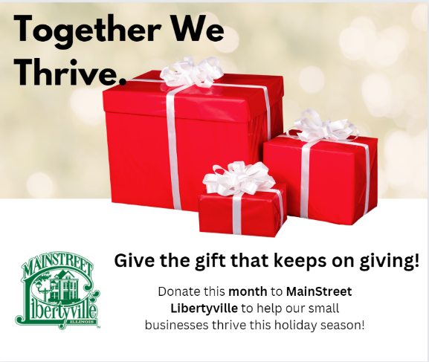 | It’s not too late to give after Giving Tuesday! In fact, giving is something you can do year-round to help our small businesses in Libertyville thrive!  From now until the end of the year, with your generous help, events like Let’s Wine About Winter, First Fridays, Farmers Market and many more will continue to be planned and enjoyed by all and will help bring more customers to our beloved businesses. It’s a WIN, WIN!  To become a member of MainStreet Libertyville, you may donate through the provided link and learn more about what we do and how your donations can help our small businesses . Thank you for your generous support.  #GivingTuesday #MainStreetLibertyville #SmallBusinesses
Giving Post #3 – Send out on Tuesday, Dec. 12
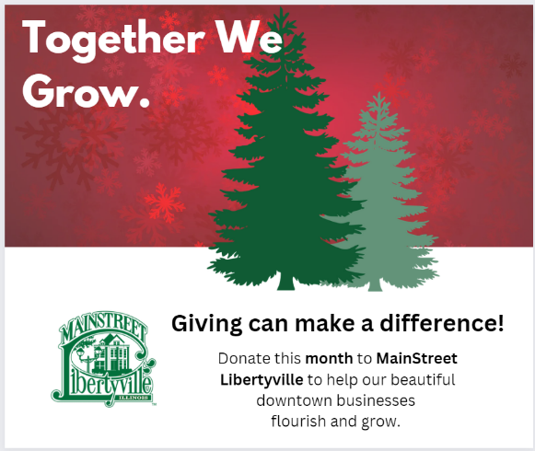 | Wouldn’t it be neat to see our small businesses in Libertyville grow beyond our wildest dreams?  Well, by donating to MainStreet Libertyville, you can! With your generous help, events like Let’s Wine About Winter, First Fridays, Farmers Market and many more will continue to be planned and enjoyed by all and will help bring more customers to our beloved businesses.  Actually, MainStreet Libertyville continues to bring 60 days of retail and community events per year, all because of YOU and your donations. Thank you for your generous support.  #TisTheSeason #MainStreetLibertyville #SmallBusinesses
Giving Post #4 – Send out on Tuesday, Dec. 19
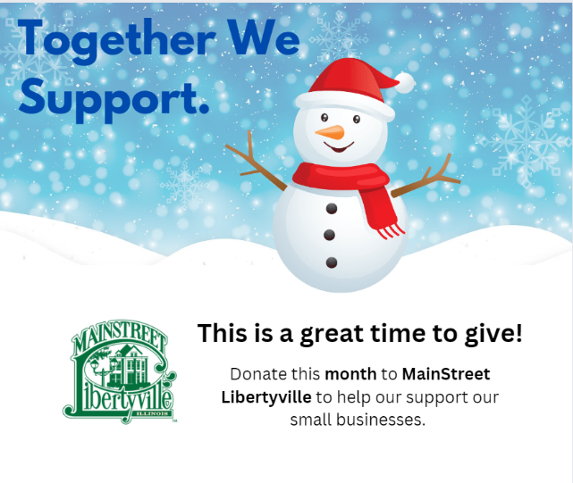 | ‘Tis the giving season! Although not always easy, giving back to your community can go a long way.  With your generous help, events like Let’s Wine About Winter, First Fridays, Farmers Market and many more will continue to be planned and enjoyed by all and will help bring more customers to our beloved businesses in Libertyville.  To become a member of MainStreet Libertyville, you may donate through the provided link and learn more about what we do and how your donations can help our small businesses. Thank you for your generous support.  #TisTheSeason #MainStreetLibertyville #SmallBusinesses
Giving Post #5 – Send out on Tuesday, Dec. 26
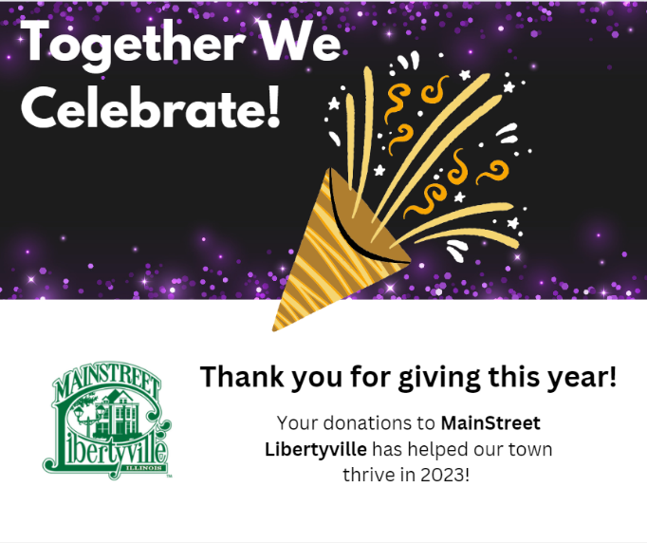 | We have a reason to celebrate! With your generous donations since Giving Tuesday on November 28, we have seen a significant increase in donations to MainStreet Libertyville! Yay!!!  With your thoughtful donations, we will continue to improve MainStreet Libertyville, our relationship with our small businesses, and our 60 retail and community events per year to help keep Libertyville vibrant.  Although the year is over, donations can be received throughout 2024 on the MainStreet Libertyville website.  #ThankIYou #HappyNewYear #MainStreetlibertyville #GivingTuesday #Donations

